**Coding Contest – 1**

**package Coding_Contest;**

**import org.openqa.selenium.By;**

**import org.openqa.selenium.WebDriver;**

**import org.openqa.selenium.chrome.ChromeDriver;**

**import org.openqa.selenium.chrome.ChromeOptions;**

**import io.github.bonigarcia.wdm.WebDriverManager;**

**public class Question_1 {**

**public static void main(String[] args) throws InterruptedException {**

**ChromeOptions co = new ChromeOptions();**

**co.addArguments("--remote-allow-origins=*");**

**WebDriverManager.chromedriver().setup();**

**WebDriver driver = new ChromeDriver();**

**driver.get("https://www.saucedemo.com/");**

**driver.manage().window().maximize();**

**driver.findElement(By.xpath("//*[@id=\"user-name\"]")).sendKeys("standard_user");**

**driver.findElement(By.xpath("//*[@id=\"password\"]")).sendKeys("secret_sauce");**

**Thread.sleep(4000);**

**driver.findElement(By.xpath("//*[@id=\"login-button\"]")).submit();**

**Thread.sleep(4000);**

**driver.findElement(By.xpath("//*[@id=\"add-to-cart-sauce-labs-backpack\"]")).click();**

**Thread.sleep(4000);**

**boolean isPresent = driver.findElement(By.xpath("//*[@id=\"shopping_cart_container\"]/a/span")).isDisplayed();**

**// Assert.assertEquals(isPresent, true);**

**if(isPresent) {**

**System.out.println("Item added to Cart !");**

**}**

**else {**

**System.out.println("Item not added to Cart !");**

**}**

**driver.findElement(By.xpath("//*[@id=\"shopping_cart_container\"]/a")).click();**

**Thread.sleep(5000);**

**boolean isViewed = driver.findElement(By.xpath("//*[@id=\"cart_contents_container\"]/div/div[1]/div[3]")).isDisplayed();**

**if(isViewed) {**

**System.out.println("Items are available");**

**}**

**else {**

**System.out.println("Cart is Empty...");**

**}**

**driver.findElement(By.xpath("//*[@id=\"checkout\"]")).click();**

**boolean checkout = driver.findElement(By.xpath("//*[@id=\"header_container\"]/div[2]/span")).isDisplayed();**

**if(checkout) {**

**System.out.println("Your Information is displayed");**

**}**

**else {**

**System.out.println("Your Information is not displayed");**

**}**

**driver.findElement(By.xpath("//*[@id=\"first-name\"]")).sendKeys("Shree Varshan");**

**driver.findElement(By.xpath("//*[@id=\"last-name\"]")).sendKeys("G");**

**driver.findElement(By.xpath("//*[@id=\"postal-code\"]")).sendKeys("613005");**

**driver.findElement(By.xpath("//*[@id=\"continue\"]")).submit();**

**Thread.sleep(5000);**

**boolean details = driver.findElement(By.xpath("//*[@id=\"checkout_summary_container\"]/div")).isDisplayed();**

**if(details) {**

**System.out.println("Overview is displayed !");**

**}**

**else {**

**System.out.println("Overview is not displayed !");**

**}**

**String product_name = driver.findElement(By.xpath("//*[@id=\"item_4_title_link\"]/div")).getText();**

**String product_price = driver.findElement(By.xpath("//*[@id=\"checkout_summary_container\"]/div/div[1]/div[3]/div[2]/div[2]/div")).getText();**

**System.out.println("Product Name : " + product_name);**

**System.out.println("Product Price : " + product_price);**

**String title = "Swag Labs";**

**String actualTitle = driver.getTitle();**

**if(title.equals(actualTitle)) {**

**System.out.println("Title Matched");**

**}**

**else {**

**System.out.println("Title not matched");**

**}**

**String url = "https://www.saucedemo.com/checkout-step-two.html";**

**String actualUrl = driver.getCurrentUrl();**

**if(url.equals(actualUrl)) {**

**System.out.println("URL Matched");**

**}**

**else {**

**System.out.println("URL not matched");**

**}**

**driver.quit();**

**}**

**}**

**OUTPUT:**

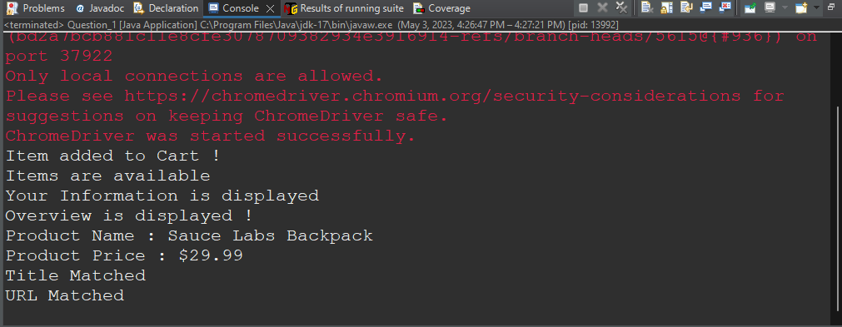

**2)**

**package Coding_Contest;**

**import java.util.ArrayList;**

**import java.util.Collections;**

**import java.util.List;**

**import org.openqa.selenium.By;**

**import org.openqa.selenium.WebDriver;**

**import org.openqa.selenium.WebElement;**

**import org.openqa.selenium.chrome.ChromeDriver;**

**import org.openqa.selenium.chrome.ChromeOptions;**

**import org.openqa.selenium.support.ui.Select;**

**import io.github.bonigarcia.wdm.WebDriverManager;**

**public class Question_2 {**

**public static void main(String[] args) throws InterruptedException {**

**ChromeOptions co = new ChromeOptions();**

**co.addArguments("--remote-allow-origins=*");**

**WebDriverManager.chromedriver().setup();**

**WebDriver driver = new ChromeDriver();**

**driver.get("https://www.saucedemo.com/");**

**driver.manage().window().maximize();**

**driver.findElement(By.xpath("//*[@id=\"user-name\"]")).sendKeys("standard_user");**

**driver.findElement(By.xpath("//*[@id=\"password\"]")).sendKeys("secret_sauce");**

**Thread.sleep(4000);**

**driver.findElement(By.xpath("//*[@id=\"login-button\"]")).submit();**

**Thread.sleep(4000);**

**List<WebElement> items = new ArrayList<WebElement>();**

**List<String> products = new ArrayList<String>();**

**Select select = new Select(driver.findElement(By.xpath("//*[@id=\"header_container\"]/div[2]/div/span/select")));**

**String sortingOrder = select.getFirstSelectedOption().getText();**

**items = driver.findElements(By.className("inventory_item_name"));**

**for(WebElement element: items) {**

**products.add(element.getText());**

**}**

**if(sortingOrder.equals("Name (A to Z)")) {**

**Collections.sort(products);**

**for(int i=0; i<items.size(); i++) {**

**if(!products.get(i).equals(items.get(i).getText())) {**

**System.out.println("Not in sorted order");**

**break;**

**}**

**}**

**System.out.println("In sorted Order");**

**System.out.println(items.get(0).getText());**

**}**

**if(sortingOrder.equals("Name (Z to A)")) {**

**Collections.sort(products, Collections.reverseOrder());**

**for(int i=0; i<items.size(); i++) {**

**if(!products.get(i).equals(items.get(i).getText())) {**

**System.out.println("Not in sorted order");**

**break;**

**}**

**}**

**System.out.println("In sorted Order");**

**System.out.println(items.get(0).getText());**

**}**

**driver.findElement(By.xpath("//*[@id=\"header_container\"]/div[2]/div/span/select")).click();**

**driver.findElement(By.xpath("//*[@id=\"header_container\"]/div[2]/div/span/select/option[3]")).click();**

**String price = driver.findElement(By.xpath("//*[@id=\"inventory_container\"]/div/div[1]/div[2]/div[2]/div")).getText();**

**if(price.equals("$7.99")) {**

**System.out.println("$7.99");**

**System.out.println("price sorted order (A-Z)");**

**}**

**driver.findElement(By.xpath("//*[@id=\"header_container\"]/div[2]/div/span/select")).click();**

**driver.findElement(By.xpath("//*[@id=\"header_container\"]/div[2]/div/span/select/option[4]")).click();**

**String price2 = driver.findElement(By.xpath("//*[@id=\"inventory_container\"]/div/div[1]/div[2]/div[2]/div")).getText();**

**if(price2.equals("$49.99")) {**

**System.out.println("$49.99");**

**System.out.println("price sorted order (Z-A)");**

**}**

**}**

**}**

**OUTPUT:**

